Insurance for you and your family
Here at Haywards Heath Town FC we work exclusively with club sponsor Vitarisk to ensure you and your family are protected when it comes to injury.
Any cover you take out provides a kickback to the club, which enables us to continue investing in kit, equipment & pitches to ensure we can continue providing football to the local community.
Below is how you can sign up and protect your family in four easy steps;
Step 1 - From the MetLife table below choose which area(s) you would like to cover:
Step 2 - We would always recommend having Core Cover, Active Lifestyle Cover, and child cover. Specialist Healthcare cover is for those in the healthcare profession.
Step 3 - Once you have chosen the covers you want, you’ll need to choose how many units of cover you want which starts at 1 and ends at 5 and the higher unit you choose the greater the cover you’ll have.
Step 4 - Simply complete the form and send to commercial@hhtfc.co.uk who will look after your information securely and we will do the rest, once we’ve placed you on cover which is immediate on receipt of your form, you’ll receive an email from us and the insurer about your insurance and we will be here to assist anytime you need.
This policy is an everyday personal protection insurance policy so should you be playing sport or at work, or when your child plays sport you have that peace of mind that if anything happens you have them covered also.
Any questions you may have we would welcome, please don’t hesitate to contact us on: 01273 980 289.
Please Note We also offer all forms of insurance so if you would like us to review any of them should that be your Life, Health, Business, Personal, Home etc. We would be happy to assist. All our quotations are a no obligation quotes to give you peace of mind before choosing to work with us or not.
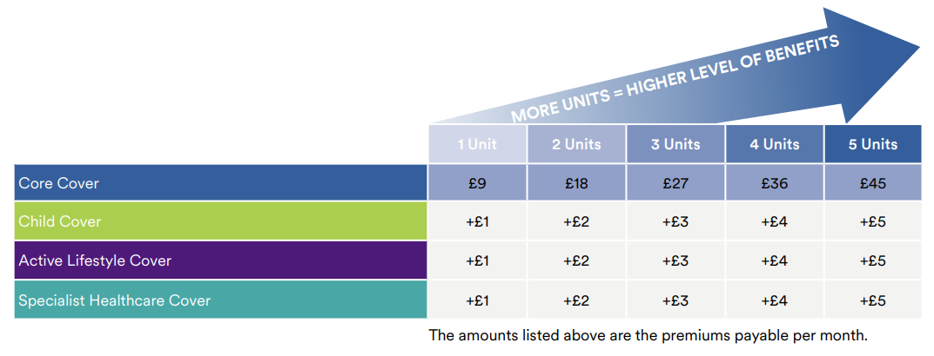
For more information on the benefits and cover provided for each level, please contact commercial@hhtfc.co.uk for the full list.

